**ISQS 5347 – Advanced Statistical Methods**

**HW 5 - One Way ANOVA**

1. Using the data from the Clubs.csv file, create formulas in an Excel file to verify the One-way ANOVA computations presented in class. While there is an ANOVA tool in the Excel Data Analysis Took-Pack, I don’t want you to use this (except if you would like another way to verify your computations). Instead, write formulas (refer to the slides for specifics of the computations) to compute the grand mean, group means, SST, SSW, SSA, MST, MSW, and MSA. Finally, divide MSA by MSW to compute the F statistic. You should be able verify all of the computations from the slides. You don’t need to “write up” the results – just be sure to label computed values in the worksheet.

For the following problems, your solution should state hypotheses and evaluate hypotheses, and state a decision and a managerial conclusion.

Ans: -

|  |  |  |
| --- | --- | --- |
| **Club.1** | **Club.2** | **Club.3** |
| 254 | 234 | 200 |
| 263 | 218 | 222 |
| 241 | 235 | 197 |
| 237 | 227 | 206 |
| 251 | 216 | 204 |

1. The Insurance Institute for Highway Safety conducts experiments in which cars are crashed into a fixed barrier at 40 mph. In the Institute’s 40-mph offset test, 40% of the total width of each vehicle strikes a barrier on the driver’s side. The barrier’s deformable face is made of aluminum honeycomb, which makes the forces in the test similar to those in a frontal offset crash between two vehicles of the same weight, each going just less than 40 mph. Suppose you are in the market for a new family car. You want to know whether the mean chest compression resulting from this offset crash is the same for large family cars, passenger vans, and midsize utility vehicles. Data from the Institute’s study are contained in the Excel file.

Null hypothesis: - Mean of all the vehicles are same

Alternate hypothesis: - Mean of the all the vehicles are not same

* 1. Run summary statistics for each of the vehicle types and create a box plot for each. Do the data look like they could have come from a normal distribution?

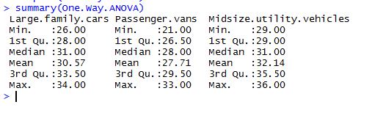

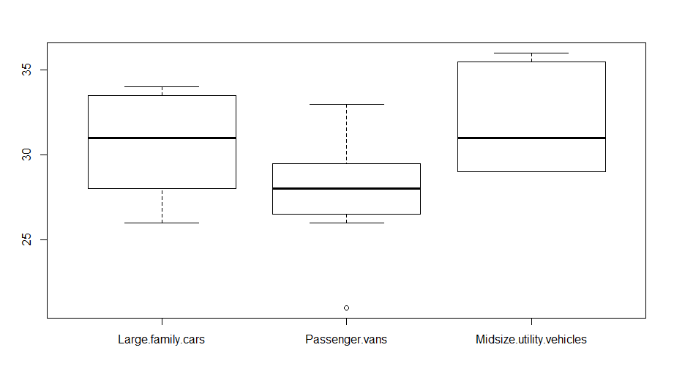

* 1. Regardless of your assessment in part a, conduct an ANOVA test at the 0.05 level of significance whether the means of chest compression are equal in all three vehicle categories.

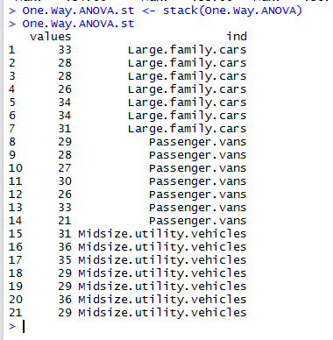

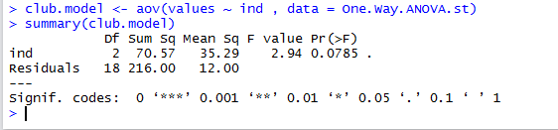

P value is 0.0785

Alfa Value is 0.05

Hence, P value is greater than that of the alfa value, we fail reject the null hypothesis.

Additionally, we can check for the Fstat > Fo we fail to reject null hypothesis



* 1. If your ANOVA results cause you to reject the null hypothesis, conduct the Tukey HSD procedure at the 0.05 level of significance to determine which mean comparisons differ.

Here we are not rejecting the null hypotheses so we don t need to conduct the tukey HSD

1. Researchers Francisco Fuentes and his colleagues wanted to determine the most effective diet for reducing LDL cholesterol, the so-called “bad” cholesterol, among three diets: (1) a saturated-fat diet, (2) the Mediterranean diet, and (3) the U.S. National Cholesterol Education Program or NCEP-1 Diet. The participants in the study were shown to have the same levels of LDL cholesterol before the study. Participants were randomly assigned to one of the three treatment groups. After 28 days, their LDL cholesterol levels were recorded. The data in the accompanying Excel file are based on this study.

Null hypothesis: - Mean of all are same

Alternate hypothesis: - Mean of the all are not same

* 1. Run summary statistics for each of the vehicle types and create a box plot for each. Do the data look like they could have come from a normal distribution?

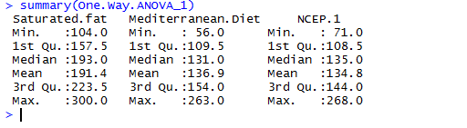

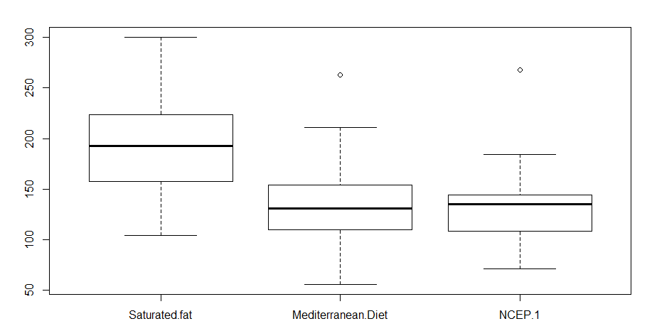

* 1. regardless of your assessment in part a, conduct an ANOVA test at the 0.05 level of significance whether the means of chest compression are equal in all three vehicle categories.

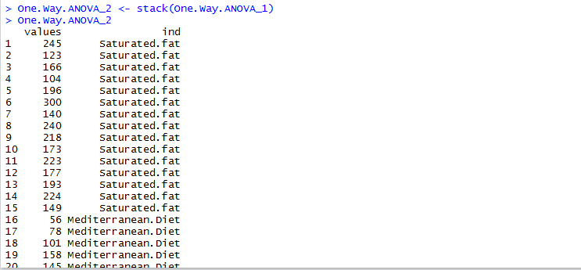

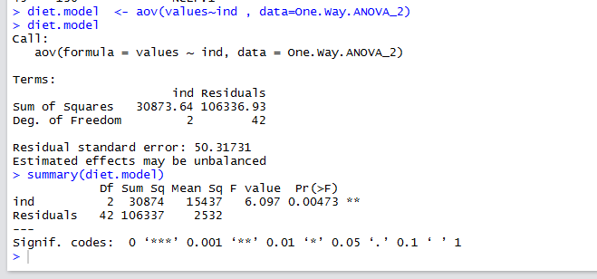

P value is 0.00473

Alfa Value is 0.05

Hence, P value is greater than that of the alfa value, we reject the null hypothesis.



Additionally, we can check for the Fstat > Fo we reject null hypothesis

* 1. If your ANOVA results cause you to reject the null hypothesis, conduct the Tukey HSD procedure at the 0.05 level of significance to determine which mean comparisons differ.

